
Welcome to
Our Lady and St Patrick’s RC Nursery and Primary School
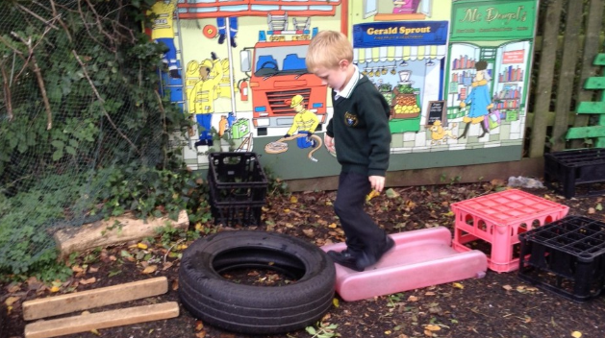 | 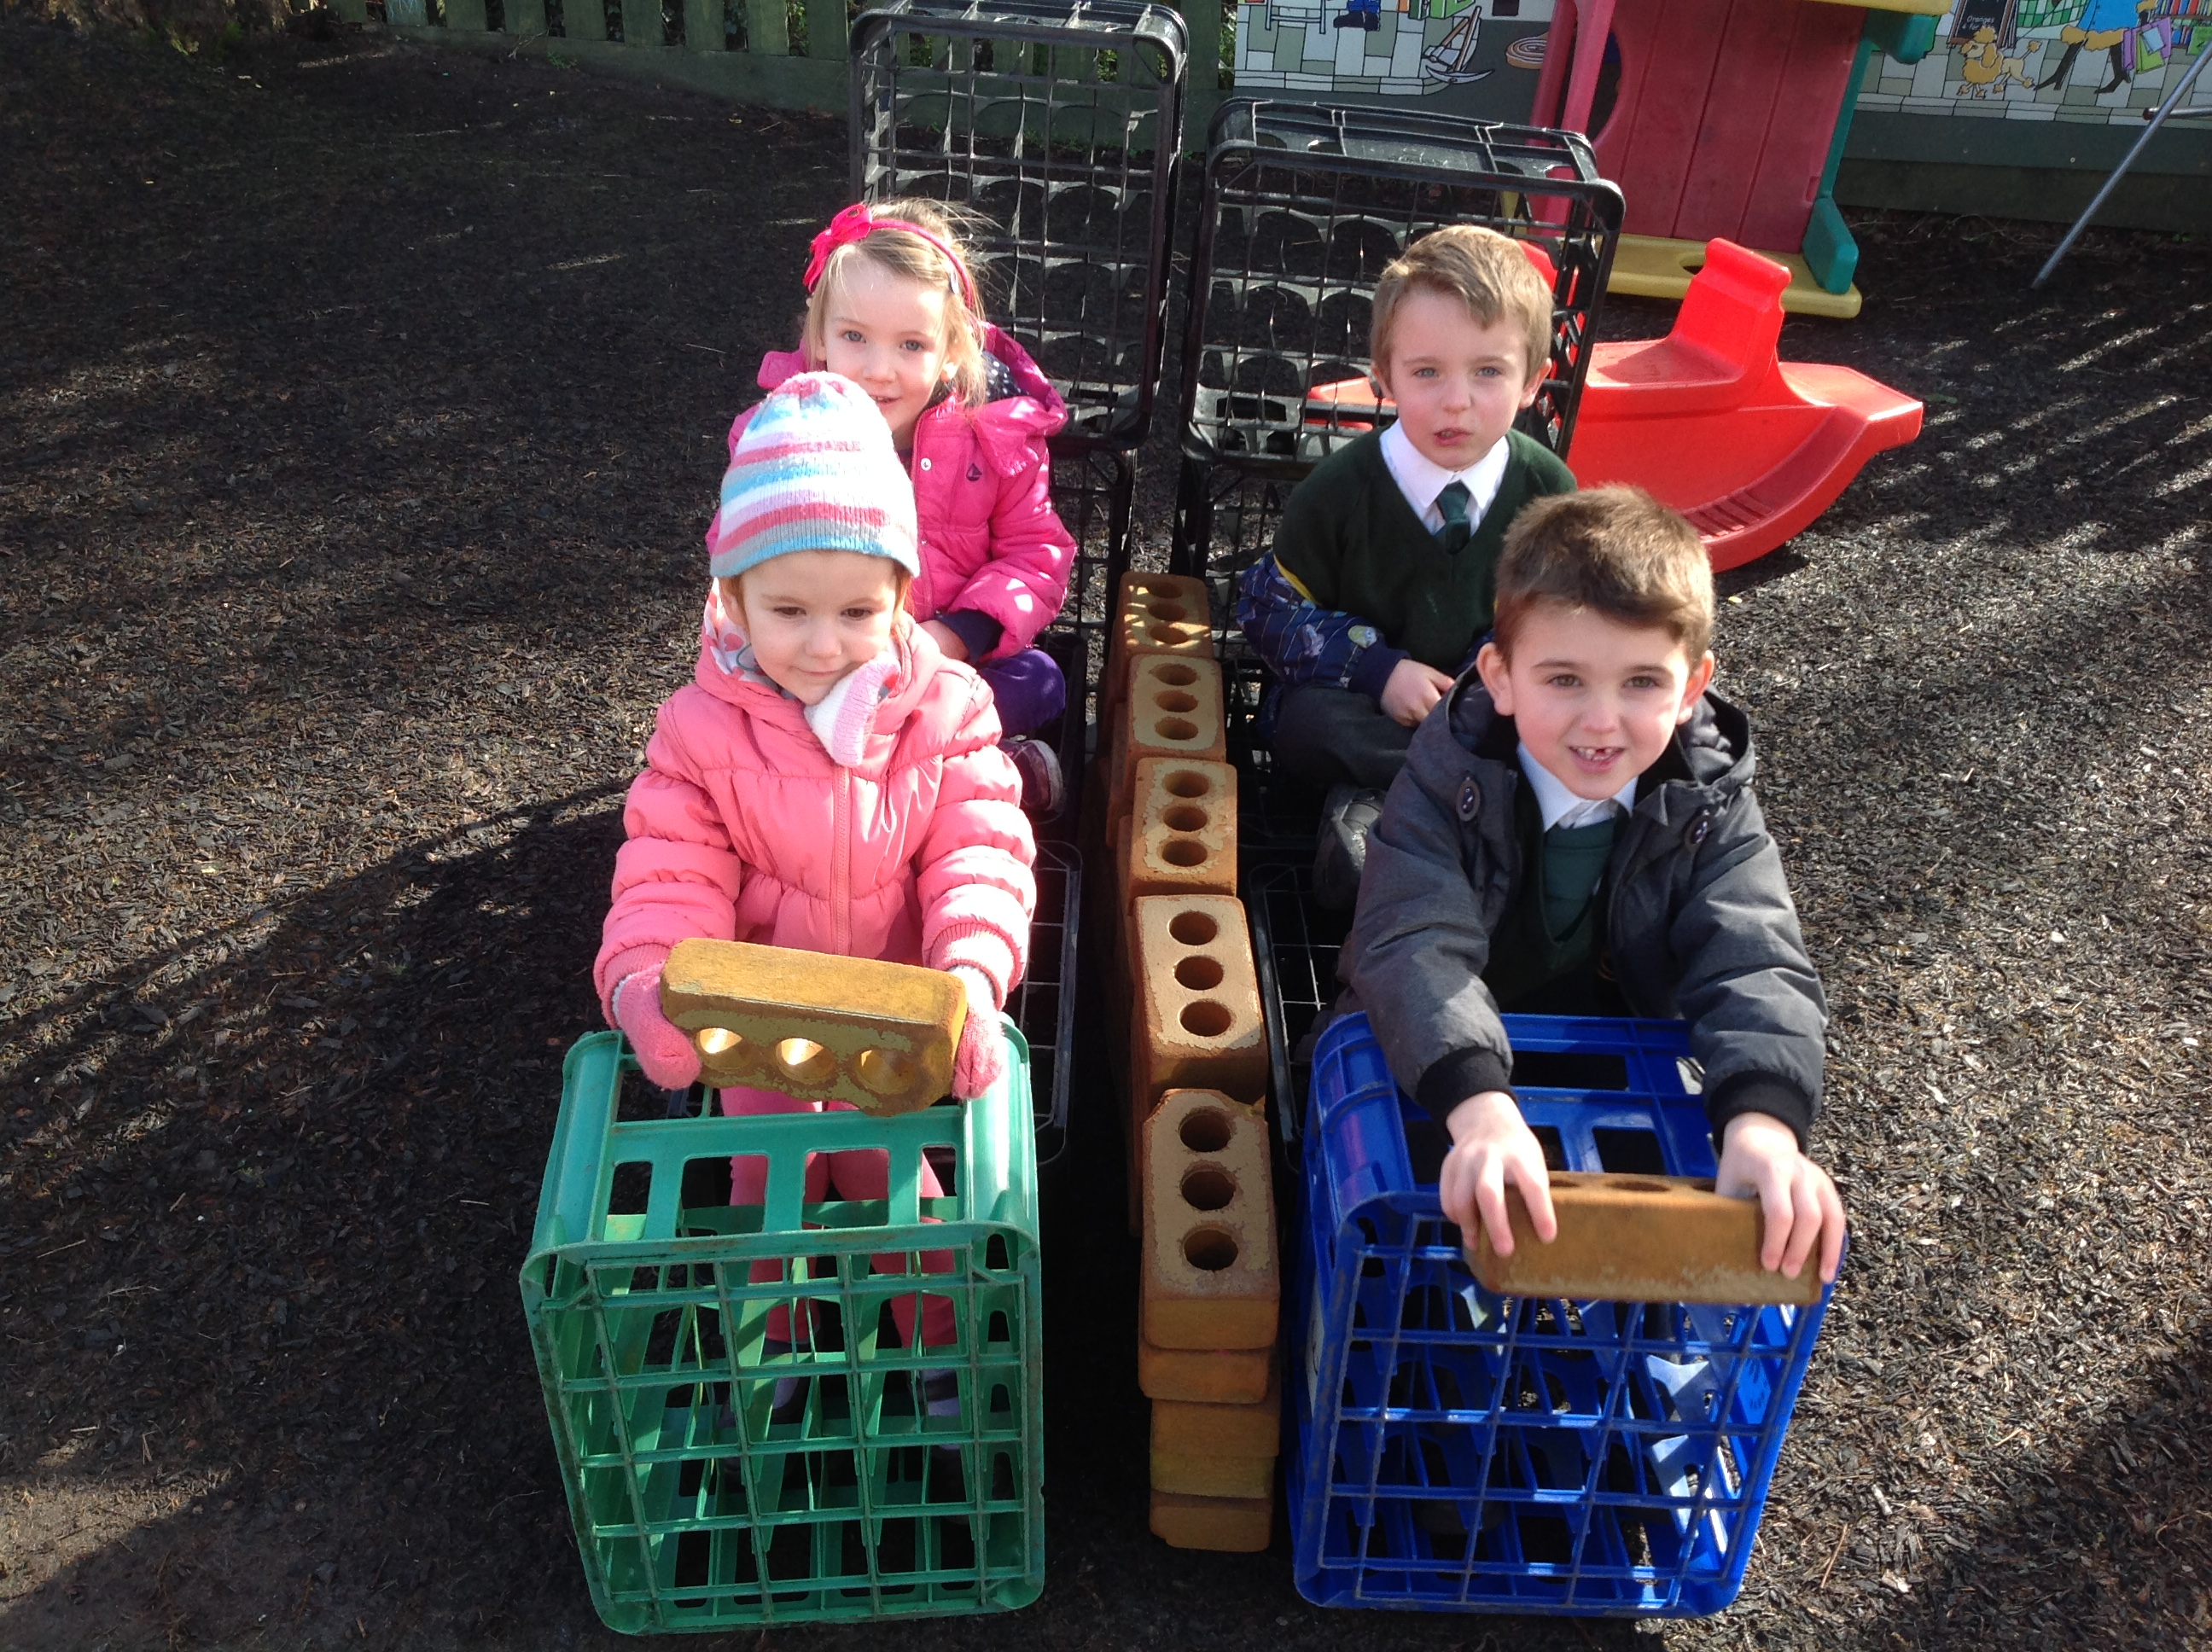
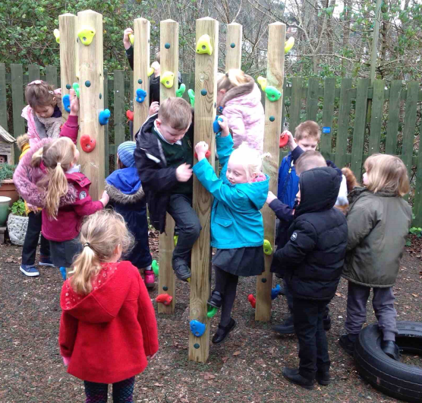 | 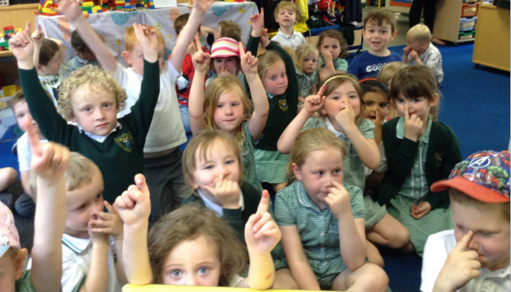
Nursery

An Introduction to the Early Years Foundation Stage (EYFS)

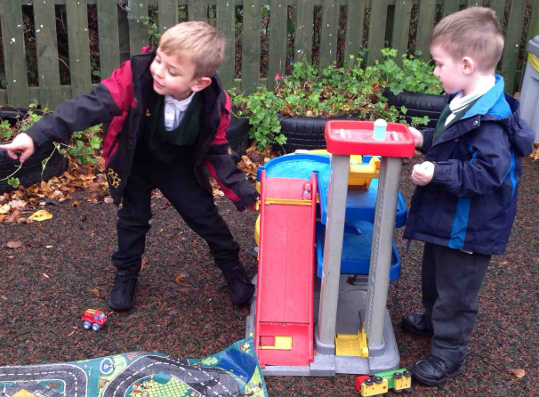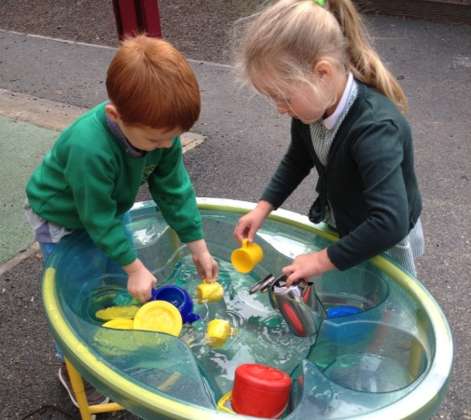

“Living, Loving and Learning Together in God’s Way”

Dear Parents,

We are looking forward to welcoming you and your child to the Our Lady and St Patrick’s Nursery and Primary School (OLSP).

We want this to be the beginning of a happy and successful time for your child and a supportive partnership with you. However, we recognise that starting nursery can be an anxious time for both children and parents. The aim of this booklet is to provide you with practical information and some useful advice to help make your child’s transition as smooth as possible.

If you have any questions or concerns, please do not hesitate to contact me.

Mrs Melissa Pearce
Nursery Supervisor
mpearce@olsp.uk

Admission and Induction
We recognise children have different needs and if you would like to discuss your child’s induction to the Foundation Unit, please contact Miss O’Kane, the class teacher. Some parents worry the longer days are a problem for the children, however we ensure we support them with this and have a lot of quiet time and time for settling and just chatting.
God Matters
The Catholic Faith and the principles of the Gospel are central to the daily life of Our Lady and St Patrick’s School.
We are committed to:
Living, Loving and Learning Together in God’s Way
Your children will be receiving the highest possible quality of education with a strong ethos of Christian love rooted in the Gospel. We would like everyone who enters into the school to feel welcomed and valued. We will celebrate the uniqueness and giftedness of each individual and everyone involved in the life of the school.
The Foundation Stage Unit builds on your child’s journey with God in partnership with you as parents and carers. We provide the basis for prayer and understanding of the Gospel in order for them to understand this journey.
Your child will join in and learn some daily prayers (copies included in this pack) as well as becoming accustomed to the rituals of Mass and other celebrations. We will follow the ‘Come and See’ RE program which allows the children to discover and learn the way in which Jesus lived and died for us.
The program also leads us into other religions to discover and experience the rich tapestry of world life. We like to think we are globally aware and eager to discover; your child will look at similarities and differences in other cultures, religions and their traditions. This allows early learning behaviours such as reflection and higher thinking skills.
We will be happy to talk through any area of this which you may feel you need to discuss.

Our Special Prayers

The Sign of the Cross
In the name of the Father, and of the Son, and of the Holy Spirit. Amen

Morning Prayer  Father in heaven you love me,  You’re with me night and day.  I want to love you always in all I do and say.  I’ll try to please you Father.  Bless me through the day. Amen.  Grace before Meals  Bless us, O God, as we sit together  Bless the food we eat today  Bless the hands that made the food  Bless us, O God. Amen  Grace after Meals  Thank you, God for the food we have eaten  Thank you, God for all our friends  Thank you, God for everything  Thank you, God Amen | Our Father  Our Father, who art in heaven  Hallowed be thy name;  Thy kingdom come;  Thy will be done on earth as it is in heaven  Give us this day our daily bread;  And forgive us our trespasses,  As we forgive those who trespass against us;  And lead us not into temptation,  But deliver us from evil. Amen  Glory be to the Father  Glory be to the Father,  And to the Son,  And to the Holy Spirit.  As it was in the beginning,  Is now and ever shall be,  World without end. Amen
Night Prayer  God Our Father. I come to say  Thank you for your love today  Thank you for my family  And all the friends you give to me  Guard me in the dark of night  And in the morning send your light. Amen | 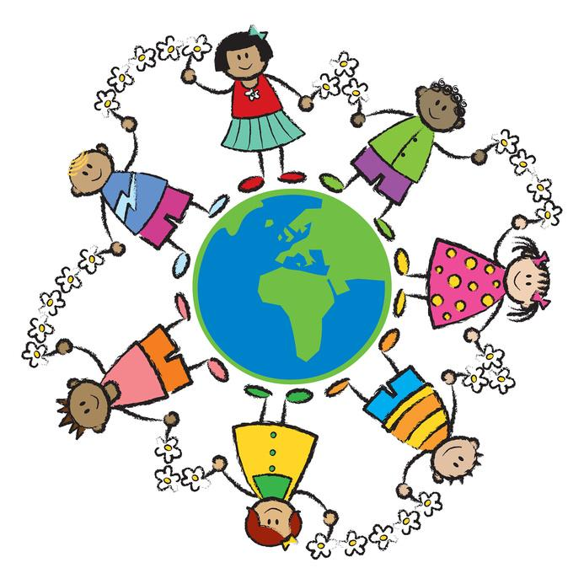


Learn Together

Being a parent is one of the most rewarding jobs in the world. We believe that you are your child’s first and most important educators.

Learning before school
During their first years of life your child has already learned skills that will help them to make a flying start at school but here are a few more things you could help your child with (if you haven’t already!):

- Feeling good about themselves
- Listening carefully
- Talking about their thoughts and feelings
- Knowing many stories, songs and rhymes
- Knowing what their own name looks like
- Recognising and knowing about letters and numbers
- Knowing about the different reasons for writing
- Wanting to learn

All these things continue to be important at school, especially the ‘wanting to learn’.
When your child starts school, the support you give them and continue to give them over the years will have an enormous influence on their achievements.

Here are some of the things that will make a real difference right from the start:

- Lots of songs and rhymes
- Listening games
- Playing with shapes
- Drawing and colouring

And perhaps the most important:

- Sharing a book everyday

Opportunities
You can provide opportunities for your child to find out, to try new things, to do things successfully.

For example:
- Going out together – talking about experiences
- Helping your child to succeed in something new

Interaction
You can interact with your child by listening, talking, making and doing things together. When your child starts school he/she will need some special attention from you. It helps to make a quiet time at home where you can:
- Listen and encourage
- Talk to each other about what they expect, how they feel, how to behave.

Modelling
Another important influence adults can have on the way that children learn comes from the way children see their adults learning. It helps if your child sees you as people who learn as well as people who know.

Expectations
Because they need the love and support of the adults they live with, children are very much affected by what is expected of them.
If very little is expected, then there is no need for them to try. They may get bored and lack the enthusiasm to try their best.
If too much is expected of them, then children may fail. They are likely to lose confidence and often choose not to attempt something new.

Your expectations need to be not too high, but not too low. It helps to think about what your child can almost do as well as what they can already do.

Recognising effort
Children’s confidence and wish to learn is based on their knowledge of what they can do. When they can nearly do something, a bit of encouragement and enthusiasm can make a big difference. This is much more helpful to children than doing something for them. If they are successful in the end – then the effort is worth making and they will get into the habit of trying hard.

It is, therefore, important that you recognise, value and praise your child’s efforts as well as their skills and achievements. Positive statements can raise your child’s self-esteem and their desire to learn.
“You listened so carefully”
“That’s good writing”
“Well done for trying”

Making a Mark

Learning about writing

The process of learning to write is a gradual one which takes a lot of effort and concentration.
Children must learn:
- How to hold their pencil
- How to use the piece of paper
- How to make their marks go in one particular direction

These basic skills help your child to become a fluent and effective writer, especially when they are younger.

Drawing and colouring is an important part of this process, which helps to develop the strength and co-ordination needed to control the pencil as well as confidence in making marks.

For a long time children’s writing will be no more than squiggles and marks. This is a very important first stage of early writing and needs lots of praise and encouragement, BUT during this time they are also developing an understanding:
- That their own names can be written down using these marks.
- That parents can use writing to make shopping lists and send cards and letters.
- That different letters stand for different sounds.
- That they themselves can make shapes that look like writing.
- That the marks have particular shapes and that these turn up in different words.
- That these shapes and marks can be put together to make words to write stories and give messages.

How parents can help
Parents can help by:
- Praising and encouraging your child’s attempts at writing
- Showing an interest in what your child has written. Ask them about it. Join in.
- Listening seriously when they explain what their writing says if they want you can scribe their message next to their own writing.
- Drawing attention to letters and words all around them, eg. Mail through the door. Letters and words in shops, in books, on videos and the television.
- Letting your child watch you writing: reading what you have written to them and telling them who the letters and messages are intended for.
- Encouraging them to add their own writing to your letters, cards, or make their own labels for toys, possessions and friends.
- Looking at alphabet books together
- Making an alphabet scrap book

Playing with sounds
Books and stories which play with words and rhymes will help children to discriminate between sounds, an important skill for reading and writing. Children love listening to these sounds and rhymes.

Repeated words and phrases can encourage children to join in. Children who have heard a lot of story language will start to use it in their play and in their writing once they start to write their own stories.

Joining the library
Public libraries have many wonderful books for young children and always welcome young members for free. Children have their own library ticket and borrow picture books, story books, information books and CDs. Libraries often have a free story time and special events.

Joining a library early in a child’s life can make a real difference to their later learning.
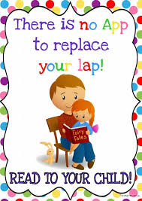



Our Lady and St Patrick’s Catholic Primary School

Answers to frequently asked questions

What things should I keep school informed about?

- If your child has any medical problems or allergies please let us know.

- In the event of sickness please ring the school before 8.30am.

- Any change in emergency telephone numbers, parents address or home telephone numbers should be notified (in writing) to the school IMMEDIATELY in case of an emergency or us needing to contact you.

- If anything changes at home - i.e. family circumstances or arrangements, please let us know.

- If you have any concerns - please make an appointment to see your child’s teacher.

How do I know what’s going on at school?

- Emails are sent out to parents via our school comms with any ad hoc information.

How do we get into the school?

- Please come to the classroom when bringing your child into school in the morning, but at all other times for security reasons, please go via the school office.

- If for any reason you are late (arrive after 8.45am) please enter school via the school office.

- For the safety of your child the car park is for the use of staff only.

Will my child need to bring a snack?

- Throughout the day children have access to milk and water and they are also entitled to receive a free piece of fruit or vegetable as part of the School Fruit and Vegetable Scheme. For additional information please visit http://www.nhs.uk/Livewell/5ADAY/Pages/Schoolscheme.aspx.

- Your child may also wish to bring their own water bottle to drink during their session.

How do I pay for School Dinners?

- The cost of a school meal is £2.81 per day. Payment can be done via our current payment system, Parentpay. Via Parentpay you will pay in and create a balance from which your child’s meal will be deducted on a session basis. You can therefore pay in as much as you would like. Under the new system you will also be able to login and see which option your child has chosen and you can set up and receive a free email when your balance falls below an amount of your choice.

- OLSP is a cashless school. We can set parents up with a Parentpay account via the school office so please visit the office staff for more information.

How will I be kept informed of my child’s progress?

- There will also be a parents’ evening in the Autumn and Spring terms. If you have any questions or concerns about your child’s progress at any time please do not hesitate to speak to your child’s teacher.

We use the following applications to communicate with parents.

Class Dojo - this is a great way for teacher and parent to communicate. Any class reminders and announcements will be posted and parents can communicate non urgent messages.

Most information and letters are sent out electronically via School Comms.
We send out newsletters fortnightly and also forms and news about events and activities.

Our Lady & St Patricks RC Nursery & Primary School Links

Please visit our website for more information:
http://www.olsp-rc.com/

Please ‘like’ our Facebook page:
https://www.facebook.com/Our-Lady-St-Patricks-RC-Nursery-Primary-School-752279774837307

Please ‘like’ our ‘Friends’ PTA Facebook page:
https://www.facebook.com/friendsofolsp

The ‘Friends’ event link:
https://www.pta-events.co.uk/friendsofolsp/

