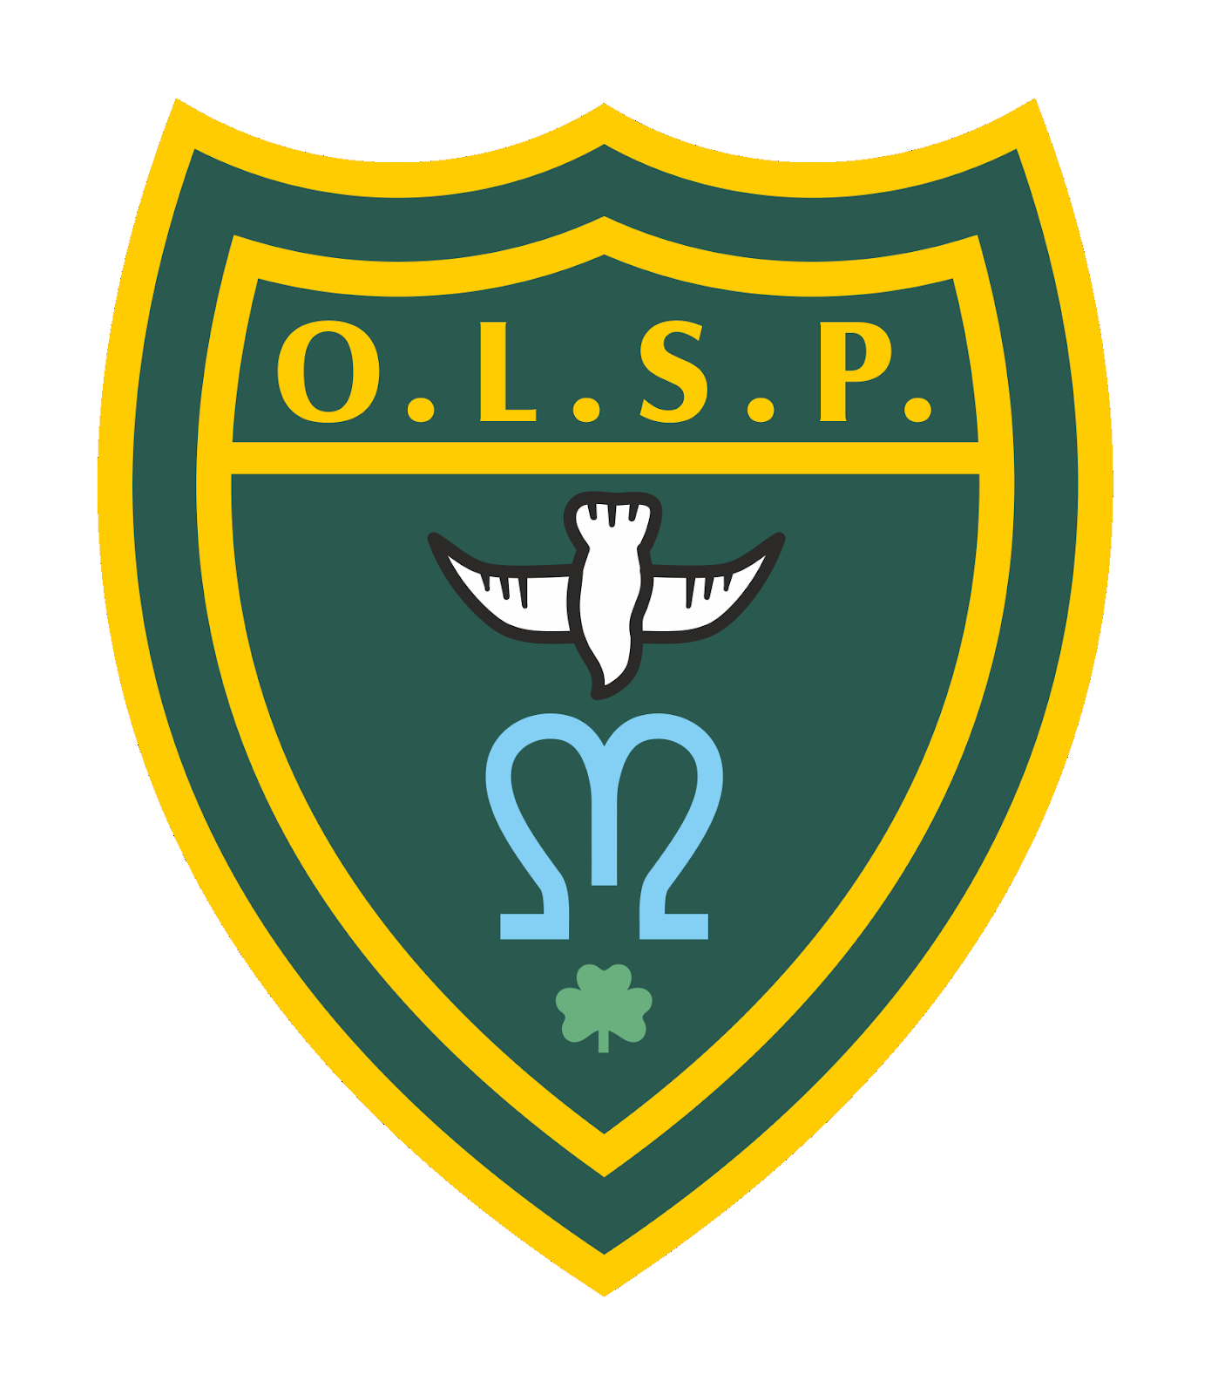

## **Our Vision for PSHE**

At Our Lady and St Patrick’s, our vision is to nurture children who are confident, compassionate and well-prepared for the challenges and opportunities of life. Through a high-quality PSHE curriculum, we equip children with the knowledge, skills and values they need to make informed, respectful and healthy choices, and to become active, responsible citizens in a diverse and ever-changing world**.**

## **Intent**

Our PSHE curriculum is built around the Ten Ten: Life to the Full programme for Relationships and Health Education (RSE), which is fully aligned with the statutory requirements and rooted in the Catholic faith. The programme promotes emotional literacy, resilience, and moral decision-making through a foundation of Gospel values and respect for the dignity of each person.

In addition to RSE, we enrich the PSHE curriculum with a wider programme of study that includes themes such as:

* Keeping safe (online and offline safety, healthy boundaries, peer pressure, and consent)
* Money and careers (financial awareness, aspirations, work and enterprise)
* Changes (including transition, puberty, and emotional wellbeing)

Our aims are to ensure that all pupils:

* Develop self-awareness, empathy, and emotional resilience
* Understand how to form healthy relationships, both online and offline
* Learn to keep themselves and others safe
* Are prepared to manage change and transition positively
* Gain confidence in making responsible financial decisions and exploring career pathways
* Are empowered to contribute positively to society through their words, actions and values

## **Implementation**

PSHE is delivered through a combination of discreet weekly lessons, class discussions, whole-school initiatives, and cross-curricular links. Learning is recorded in a class floorbook, capturing pupil voice, creativity, and the progression of ideas throughout the year.

Our whole-school approach to PSHE includes the following:

* "Life to the Full" is taught in sequenced modules across the school, covering Created and Loved by God, Created to Love Others, and Created to Live in Community
* Teachers follow a spiral curriculum that revisits key concepts in an age-appropriate and progressive way
* Lessons include drama, role-play, storytelling, videos and discussions, allowing children to engage actively with the material
* Wider PSHE themes (e.g. keeping safe, money and careers, and changes) are explored through focused lessons, assemblies, themed weeks and class projects
* Teachers create a safe, inclusive learning environment where children feel comfortable expressing themselves
* Children's learning is celebrated and documented through the class floorbook, which showcases reflections, collaborative tasks, and follow-up activities
* Parents and carers are engaged through regular communication and access to Life to the Full parent resources

## **Impact**

The impact of our PSHE curriculum is that children leave Our Lady and St Patrick’s with a strong sense of identity, self-worth, and moral purpose. They will:

* Understand how to build and sustain healthy relationships
* Have the tools to manage emotions and challenges in a positive, thoughtful way
* Feel empowered to make safe and informed choices
* Demonstrate understanding of financial literacy and career aspirations
* Be ready to adapt to change with resilience and confidence
* Contribute meaningfully to their communities with compassion and integrity

The use of class floorbooks allows teachers to assess learning through pupil voice, class dialogue and written reflections. These books serve not only as a record of progression but also as a celebration of the children’s growing understanding of themselves and the world around them.