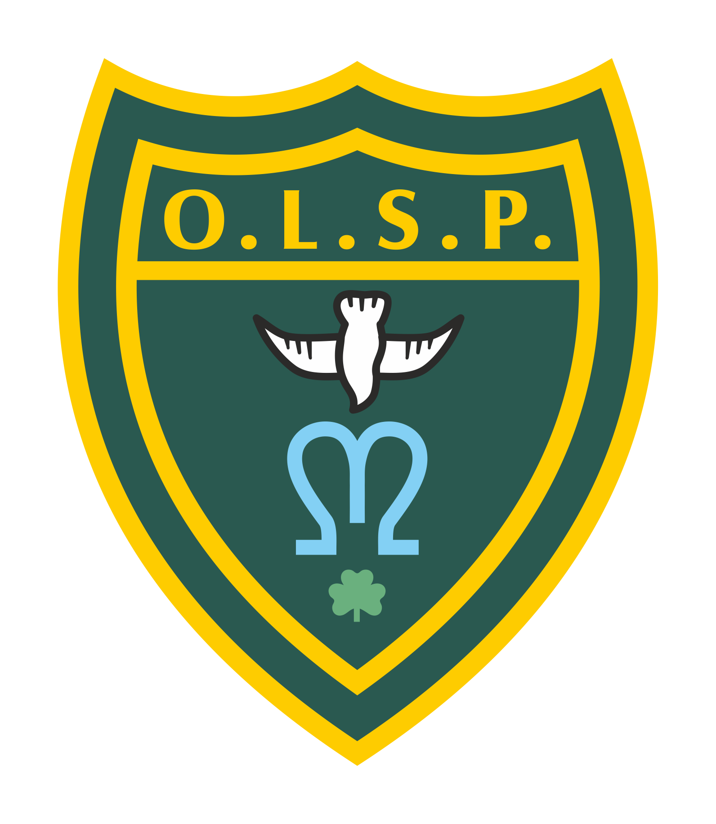
Our Lady and St Patrick’s RC Primary School

Summer 2 2026 Curriculum Newsletter

Moons Class

 | Teacher’s Message | Welcome back to the final term of EYFS!  This half term is a long one with lots of exciting events including the school BBQ and sports day.  Please ensure your child has a filled drinks bottle, sun hat and has applied suncream on sunny days as we will be spending lots of time outside.
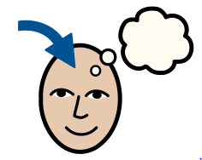 | Homework | Please ensure your child brings their reading folder to school each day. All children will now be bringing home blending or reading books and should be practising reading these at home with you.  Reading: Reading will be our main focus for homework.  Phonics groups: The children who are currently part of a phonics group should bring home a bookbag book which you can share together as it will be a new book. They should also bring home a smaller phonics book which they will have read 3 times within their group so should be familiar with. The children were assessed before the end of the year and know their groups for this half-term.  Spellings:  Phonics groups: Within the smaller phonics books that the children will bring home, it highlights (circles at the front) the sounds we are focusing on in class, the speedy green words and red words. Please look at these together.
 | Reading for Pleasure | This half term as a class, we will be reading a selection of wonderful stories together. These will include:  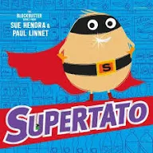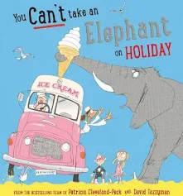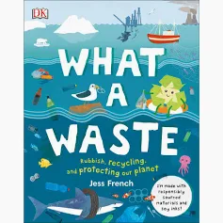
 | English | This half-term in English, we will be reading our new text ‘Supertato’. The children will explore the text, predicting what will happen by reading the blurb, and engage in lots of drama reenacting scenes from the book! Children will also be exploring letters and have a go at writing their own, using common exception words that we have already learned, such as ‘to’ and ‘I’ and ‘he’.
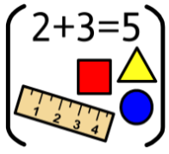 | Maths | In maths, children will continue to work on learning their number bonds to 10, which they started prior to the break. The will also be counting on from 20 and recognising the repeating patterns of 10s and 1s when counting.
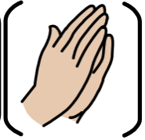 | RE | In RE, we will be beginning a new unit called ‘Dialogue and Encounter’ where the children will learn about religions outside of Christianity.
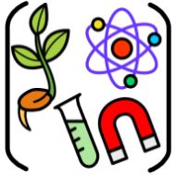 | Science | In Science this half-term, the children will learn about the seasons and how they change. They will also learn about contrasting environments with different climates.
 | Geography
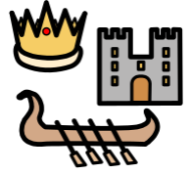 | History | In ‘past and present’, children will learn about holidays and how these may have been different in the past. We will explore the popularity of seaside holidays that were journeyed to on steam trains, and explore popular activities of the past.
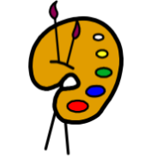 | Creative arts | In our creative art unit this term children will continue to create using a variety of resources, using different methods of decorating and adhering materials together. The will be encouraged to talk about their creations to begin learning about the evaluation process.
 | RSHE | In RSHE, children will learn all about how to keep safe in the sun and at the beach! They will learn about water safety and what different lifeguard flags mean. They will learn about suncream and sunglasses and why we need to cover up in very hot weather.
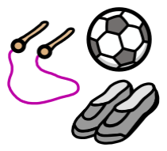 | PE | PE this half term will be held on Tuesdays and Thursdays. Children will be focusing on gross motor skills, passing using balls and bean bags. They will also start to practise running races in anticipation of sports day later on in the term.
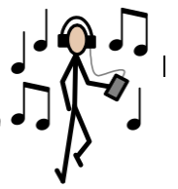 | Music | In Music this term, the children will be singing and rhyming with Mrs Newton-Browne on Wednesday afternoons.
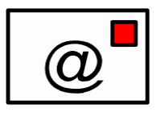 | Teacher contact: | Please come and see me if you have any worries or concerns. If this isn’t possible then please contact us through Class Dojo.  Please note that teachers are teaching from 8.30am - 3.15pm. If your contact is urgent please contact the school office office@olsp.uk during the school day.  There is no requirement for a teacher to reply to email or class dojo messages received in the evenings or at the weekend.

