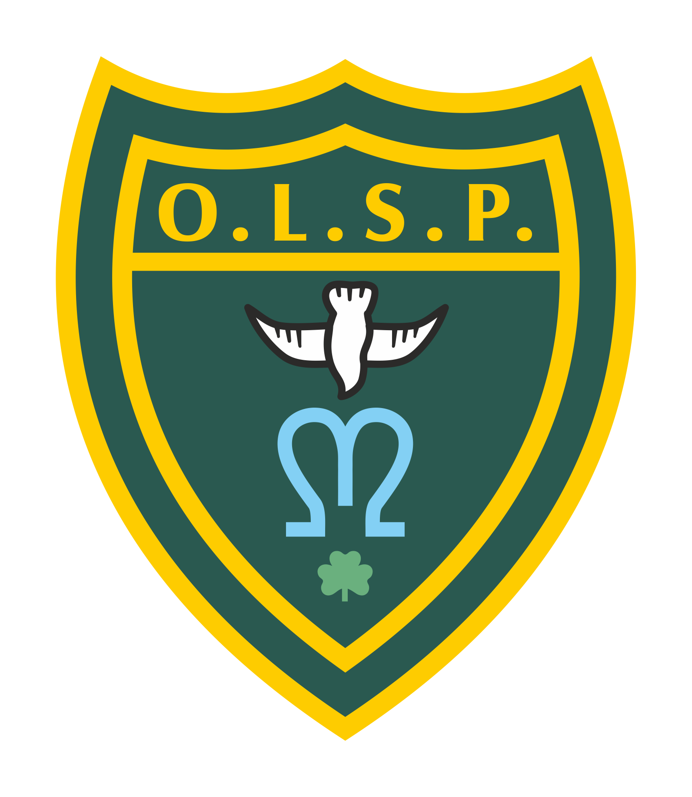
Our Lady and St Patrick’s RC Primary School

Autumn 1 2026 Curriculum Newsletter

Moons Class

 | Teacher’s Message | Welcome to Reception at OLSP!  We have an exciting year of learning and play planned for your little ones as they begin their school journey.  Please do not hesitate to come and speak to any of the EYFS staff if you have any questions or worries - someone will always be at the door in the morning and after school!
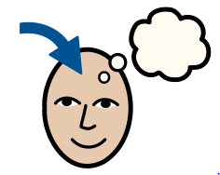 | Homework | Children starting in reception will not be bringing home phonics books until they have moved past learning their initial sounds. This will be after half term at the earliest.  For now, please enjoy sharing books with your child. We have books available at our office if you are in need of more texts.  Reading: Reading will be our main focus for homework.  Phonics groups: The children who are currently part of a phonics group should bring home a bookbag book which you can share together as it will be a new book. They should also bring home a smaller phonics book which they will have read 3 times within their group so should be familiar with. The children were assessed before the end of the year and know their groups for this half-term.  Children on AR: Those children that are now reading AR (Accelerated Reader) books need to be reading at home and quizzing in school. Each morning, they will have the opportunity to quiz in school on a chrome book.  Spellings:  Phonics groups: Within the smaller phonics books that the children will bring home, it highlights (circles at the front) the sounds we are focusing on in class, the speedy green words and red words. Please look at these together.  Children on AR and not in a phonics group: These children will receive weekly spelling, punctuation and grammar homework. This will be sent home on a Friday.
 | Reading for Pleasure | This half term as a class, we will be reading a selection of wonderful stories together. These will include:  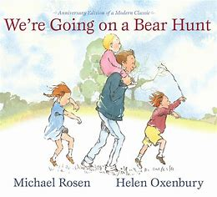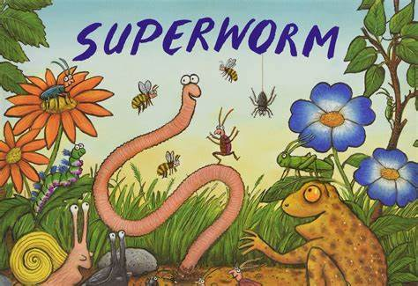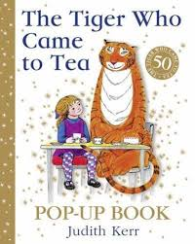
 | English | This half-term in English, we will be beginning a new unit of work based on the book, ‘We are going to find the monster!’.  The children will be exploring the story and learning to retell. As we move through the half term, they will start adding some initial sounds (‘m’ for monster) alongside their drawings.  Some children may be able to use their phonics learning to start writing some words.
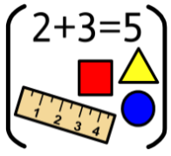 | Maths | Reception: In Maths this half term, Reception will be learning to refine their counting skills with numbers up to 5. Many children can recite their numbers, but we will be focusing on counting objects accurately in groups and lines, reading dice, organising objects to count and learning about ‘0’.  We will then move on to comparing quantities.
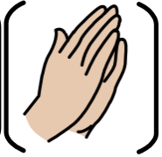 | RE | In RE, we will be beginning a new unit called ‘Creation and Covenant’ and the children will be learning that God created them as they are. We will be thinking of our families, our communities, and the world around us, and how we can take care of the world.
 | Science | In Science this half-term, we will be learning all about animals including humans! We will learn all about ourselves and what makes us different to other animals.
 | Geography | Not a lead subject
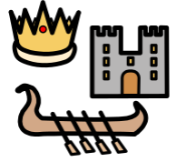 | History | Our history learning will be all about the children’s lives so far and how they have changed over time. We will look at pictures of babies and discuss how everyone changes as time progresses.
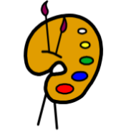 | Creative arts | The children will be practising painting skills! They will learn about primary colours and look at the work of Mondrian.
 | RSHE | In RSHE we will be learning about hygiene, specifically hand washing and teeth brushing.
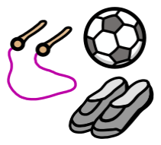 | PE | The children will have two PE lessons a week and will need to make sure that they have their PE kits available in school. Part of the EYFS curriculum means children need to practise changing in and out of clothes, although adults will always be available to help!  Children will practise gross motor skills such as throwing, running and jumping, as well as fine motor skills.
 | Music | In Music this term, the children will be singing and rhyming with Mrs Knock on Wednesday mornings.
 | Teacher contact: | Please come and see me if you have any worries or concerns. If this isn’t possible then please contact me through Class Dojo.  Please note that teachers are teaching from 8.30am - 3.15pm. If your contact is urgent please contact the school office office@olsp.uk during the school day.  There is no requirement for a teacher to reply to email or class dojo messages received in the evenings or at the weekend.

